GRE Preparation

# General

* **Learn from your mistakes!** Dissect your thought process and work from there!
  + What mistake did you make?
  + Why did you make it?
  + How did you make it?
* Ask **what’s the trap** on every single problem? The same traps repeat again and again!

# Verbal

## Sentence completion

* **Come-up with one ‘simple’ word that fills the blank**
  + Break down the long sentence in your own words. Only ignore content like names and facts (e.g., in italics)
  + Find the ‘qualifier’ phrase in the sentence that helps to narrow down the definition (e.g., by describing it or drawing a parallel/contrast). Pick a word to match this.
    - **Determine if blank has +/- connotations**
    - **Take into account sentence single/double/time/perception shifts.**
    - **Avoid false shift words!**
  + The answer should match your ‘simple’ word, **by definition**
  + Use this technique to **eliminate bad answers**
  + **Never choose a word that ‘kinda’ works**
  + Plug words back in **at worst-case to validate answer**
  + **Avoid trap words -** words that might relate to the “content” of the text, but not relevant for the particular ‘blank’
  + **Don’t try to impute meaning - e.g., ‘far afield’ to represent something other than it’s core definition**
* **Identifying unknown words**
  + **Roots:** Are there any similar syllables that you can leverage?
    - **E,g,, intransigent for ‘not moving’**
  + **Prefixes:** Are there any prefixes that you can leverage? E.g., dispassionate based on displeased etc.
    - Note: There are edge-cases (e.g., invaluable = very valuable
* In the ‘pick two similar words’ section
  + **Remove non-synonyms and identify the pairs (meaning + connotation)**
  + **Plugging in word shouldn’t change meaning of passage**
  + **Sense-check: Are the two words you have picked synonyms (in context - if you add both words in, does they both match a simpler word?)**

**YN_aN_b -> YN_a or YN_b or N_aN_b**

**Y_aY_bN -> Y_aN, Y_bN, Y_aY_b**

* + concentrate on ensuring the words **have pairs** in addition to ensuring they are correct in context- e.g., hobbled / hamstrung / scrapped - scrapped, while relevant, **is the odd-one-out!**
  + Look for exact similarities in meaning
* Two-blank / Three-blank questions:
  + Traps:
    - Phrases / words in sentences superficially connected to wrong answers
    - Answer choices that are similar and *almost* fit
    - **Pick truly clear (unambiguous) fits**
    - **Make sure the picked blanks refer to the correct subject** (e.g., may be relevant to sentence, but not relevant to the subject of the blank) **and the blank really refers to the qualifier phrase in the text** (e.g., does word X really mean that Y?)
  + Read the entire paragraph - put blanks in context of the entire paragraph, and not sentences just around it. **Predict answer-choices first!**
  + Blanks sometimes depend-on each other - **understand connections between blanks, write-out all options** and identify **most appropriate choice based on answers available**
    - Use + / - to help narrow down
    - **Opposites should be ‘direct’ opposites - e.g., focus vs. digression**
    - **If narrowed down to two-choices, pick option that is most relevant to the context. Double-check the third option is not more appropriate**
  + Solving tough triple-word sentences:
    - Paraphrase meaning and decode hard words
    - Fill-in blanks with temporary words
    - Fill-in blanks with chosen woods and sense-check
    - Focus on words you *do-know*
    - Read everything!
    - **In worst-case, solve last blank first and work back**

## Reading comprehension

* **Key-tricks:**
  1. Ways of eliminating answers:
     + **Potential vs. definite** in answers (definite often pushes it too far)
       - **Do not pick the most extreme / negative / complex**
     + **Faux wording at end of sentence -** e.g., is ‘X’ but answer refers to ‘Y’
     + **Specificities in the title** - e.g., are you talking about a specific quote in the passage? Use this to filter-out answers.
     + **Double-check interpretation of qualifier** if one option is vague vs. another option is “caught-out” by qualifier, e.g., does “if not previously occupied” in-reality mean “empty”. Does “graphic” = photo or visual
     + Check whether **explicit references exist to the text**. **If fretting for a long-time on very specific details (e.g., tone), select and move-on**
  2. Mark answers with an ‘X’ if they are **categorically wrong** and a ‘?’ if not enough information is available
     + If need to ‘jump’, select answer where ‘jump’ is minimal
  3. In ***except***questions, the answer may not even appear in the text.
     + Check whether content appears first before trying to argue a way through. **Don’t overthink**
  4. In ***main point*** questions:
     + **High-level topic - 1 -** e.g., not ‘thermodynamics’, but ‘thermodynamics as applied to pistons’
     + Pay attention to plurals etc. Is it about one item or multiple items? **Don’t just bias to the first sentence of text**
     + Double-check it covers big topics in text - if not, then got to **high-level topic** (see summary you have written)
  5. In ***purpose*** questions:
     + Work-back from the “conclusion” of the text - the point is not “just” to cover the content as described in the text
  6. In ***similar word*** questions:
     + Check if the replaced word has **explicit context / backing in sentence -** e.g., does it really imply ‘ignorance’ or are you projecting?
  7. In ***which role*** questions:
     + Check the sentence to **see if it explicitly matches with the option**. Does it *really* justify the methodology, or are you reading into it?
     + **evidence =~= support,** but **summarize =/= support**
  8. In ***parallel*** questions
     + Avoid metaphors that **have the same theme** as the passage
* **Active reading**
  1. Note down ‘shifts’ in the content - e.g., however, recently scientists found … etc.
  2. **Purpose** - What does the passage aim to do? E.g., argue a point, explain a concept, analyse two different viewpoints
  3. **Main idea** - What is the passage about? What is the focus (e.g., high-level or something specific)?
  4. **Structure** - How is the passage structured? E.g., hypothesis, describe methods, results and implications. **Write-own main idea of each paragraph when reading through - 5-8 words**
  5. **Tone** - What is the tone of the passage? Positive or negative? How positive or negative?
  6. **Ignore detail** - Only read detail that is relevant to purpose / main idea / structure / tone
     + First / Last sentences of paragraph
     + Sentences with some ‘transition’ words (e.g., not ‘for example’ etc.)
* **Guide to answering questions:** 
  1. **Paraphrase question to simplify it**
  2. **Predict answer to question before reading answers**
  3. **INCORRECT ANSWERS:** Is the answer choice blatantly incorrect?
  4. **IRRELEVANT ANSWERS:** Does the answer contain content that is valid to the passage? **Is this content valid to the question? Trick answers will mention:**
     + **Something discussed elsewhere in passage as ‘true’ but not relevant to the question**
     + **Something that is ‘common sense’ but not substantiated in text**
  5. **QUALIFIED ANSWERS:** IIf there are multiple final answers, are there any **qualifiers** in the answer that render it incorrect? Is there anything that can help you split **A from B?**
     + **What is the ‘trick’ word? E.g., Melville passage - inclusion of the word ‘genre’ which is a step too far**
     + **Look out for ‘only’ etc.**
  6. **LEAP ANSWERS:** Does the answer **require a leap-of-faith** from what is detailed in the passage?
     + **Avoid generalisation - take ‘baby steps’ away from passage**
  7. **SENSE CHECK:** Ensure a correct level of **substantiation in the passage** - does a sentence categorically detail this answer?
     + **Is there a condition under-which the answer needs to be right? E.g., this would be true if….**
* **Select word in sentence**
  1. Treat it like a ‘text completion’ and **come-up with your own word**. Important: Resist the urge to plug in answer choices!
  2. The choice you pick **must be a dictionary definition** of the word in quotation marks
* **Primary purpose questions flaws**
  1. **Too general / vague answers - it’s not topic X, it’s topic X as embodied by example / deep-dive Y**
  2. Too specific answers (e.g., only relevant to one part of paragraph)
  3. Mentions something not in passage
  4. ‘Rotten spot’ - e.g., bad qualification
  5. Answer that is closest to your answer is probably the best one!
* **Inference questions**
  1. Inference answers are inescapably true, based on the information available in the text (will share close similarities with text).
  2. **Check for the presence of ‘all’** - if *not* extreme and backed-up in passage, then likely to be true
     + **True ‘if’ = Incorrect, True ‘because’ = Correct**
     + **Paraphrases of passages** are *not* inferences. **Inferring with common sense** is also not an inference
  3. **If there is an extra unknown in answer - e.g., if this is also true, then answer is correct - INCORRECT (answer must definitely hold true)**
* **Identify the structure questions -** Summarise + simplify highlighted text. Understand how this relates to sentence before and sentence after
* **Elements of the argument**
  1. A leads to B, C leads to D -> A only leads to D if B = C. Spot the **‘gaps’**!
  2. Think of the **unstated assumption before going through answer choices**
  3. For assumptions, **negating the assumption should break the conclusion**

# Writing

## General tips

* **Timings**
  + Brainstorm and outline (3 mins)
  + Intro and thesis statement (3 mins)
  + Write the body + examples (20 mins)
  + Write conclusion (2 mins)
  + Edit (2 mins)
* Use link words - **meanwhile, of course, ultimately**

## Quotes

The only good is knowledge and the only evil is ignorance – **Socrates**

A people that value its privileges above its principles soon loses both – **Dwight D. Eisenhower**

In theory, there is no difference between theory and practice. But in practice, there is – **Yogi Berra**

A little inaccuracy can sometimes save a ton of explanation – **H.H Munro**

Any intelligent fool can make things bigger, more complex and more violent. It takes a touch of genius – and a lot of courage – to move in the opposite direction – **E. F. Schumacher**

A consensus means that everyone agrees to say collectively what no one believes individually – **Abba Eban**

Non-cooperation with evil is as much a duty as is cooperation with good – **Mohandas Gandhi**

Whatever government is not a government of laws, is a despotism, let it be called what it may – **Daniel Webster**

Good people do not need laws to tell them to act responsibly, while bad people will find a way around the laws – **Plato**

Far and away the best prize that life offers is the chance to work hard at work worth doing – **Theodore Roosevelt**

It is dangerous to be right, when the government is wrong – **Voltaire**

The will of the people is the only legitimate foundation of any government, and to protect its free expression should be our first object – **Thomas Jefferson**

No nation is fit to sit in judgment upon any other nation – **Woodrow Wilson (28th U.S President)**

The artist is nothing without the gift, but the gift is nothing without work – **Emile Zola**

The world is full of educated derelicts – **Calvin Coolidge**

A lie gets halfway around the world before the truth has a change to get its pants on – **Winston Churchill**

It’s not the size of the dog in the fight, it’s the size of the fight in the dog – **Mark Twain**

Life contains but two tragedies. One is not to get your heart’s desire, the other is to get it – **Socrates**

If women didn’t exist, all the money in the world would have no meaning – **Aristotle Onasis**

Men are not disturbed by things, but the view they take of things – **Epictetus**

As a rule, men worry more about what they can’t see than about what they can – **Julius Caesar**

## Issue

* **Thesis**
  + Choose your thesis: strongly agree / disagree, moderately agree / disagree
  + For moderate: have three points (2 one side, 1 on the other)
* **Structure:**
  + Introduction
    - **Hook** (generalisation anecdote, trend, quote): **introduces the topic**
    - **Shift to prompt** - shift introduction of your topic to the thesis being discussed
    - **Thesis** - State the thesis for our essay (**very important**)
    - **Outline** (structure of response) - e.g., “**For X reasons**”
  + Body
    - Topic sentence that introduces support idea
      * **Imperative!**
    - Example
      * Add a good example (from history / politics / economics). Worst-case hypothetical
    - Development / Explanation
      * What is implication of your example on your supporting idea
      * Why does this matter based on your thesis?
  + Conclusion
    - **If strong thesis**
      * Introduce a counterpoint from someone the other side might use to argue against your position. **But shoot this down!**
      * **Wrap-it-up**
    - **If medium theis**
      * Explain how issue is complex and there is no easy answer
      * Rephrase thesis and **wrap-up**

## Argument

* **Logical fallacies**
  + **S - Similarity is assumed -** 50-65 years old in town X did Y, we should do the same to 50-65 years old in town Z. **Are these 50-65 years olds the same?**
  + **E - Extrapolation - Apples aren’t oranges** - If it worked for X, it should work for Y - e.g., X = Y
  + **N - Numbers and percentages** - e.g., a number when it should be a %
  + **E - Evolution**- In 1985, ….; therefore we should do X
  + **C - Causation vs. correlation**- After we did X, we saw Y - we keep doing X
    - What cofounders Z affected this?
  + **A - Ambiguous language** - “In better shape”, “In normal diet”
    - What must the argument do to make the language less vague - e.g., quantify, defining X terms
  + **S - Don’t trust a survey** - According to the latest survey
* **Safety points**
  + **Propose further research** - Are there any viable alternatives to the proposed actions that could be helpful to investigate? Give examples - e.g.polling!
  + **Consider knock-on effects** of the proposed action - e.g., brand loyalty!
* **Structure**
  + **Introduction**
    - Rephrase main conclusion from argument
      * E.g., the argument states Y, which leads to Z
    - Identify author’s evidence and/or premises - the main one
    - Thesis: **follow the specific task instructions.** 
      * **Before this recommendation can be properly evaluated, three key questions need to be addressed?**
      * **This should refer back to the task instruction**
  + **Body paragraph**
    - Supporting idea (making sure to follow specific task instructions)
    - Example 1 (making sure to use ‘maybe’ language)
    - Example 2 (making sure to use ‘maybe’ language)
    - **Effect on conclusion if examples prove true** 
      * If either of these scenarios have merit, then the conclusion drawn in the original argument is significantly weakened
  + **Conclusion**
    - Statement that the argument, as it stands now, is flawed
      * Because the argument makes several unwarranted assumptions, it fails to make the convincing case that X
    - Request for more evidence
      * To be more compelling, the author needs to provide evidence for the three questions identified above and, only then, would we be able to evaluate...
    - **Statement of how evidence will help evaluate the argument more effectively**
      * **See above**

# Math

* **Important notes:** 
  + **Read the question!**
  + 1 is not a prime number, 2 is a prime number
  + Do not calculate standard deviations!
  + Divisors include *everything* - not just prime factors
    - # of divisors - apply pigeon-hole principle to prime factors.
    - Make sure to add 1 to the exponent (e.g., *don’t* use it)
    - When counting divisors, not ‘0’ divides into any number 0 times!
  + **Backsolve if you find yourself arriving in a cubic scenario**
    - **Start with middle number and then go up or down depending on answer**
  + **The diagrams are misleading** - if angles/lengths aren’t specified, there is no assumption that they mimic what exists in the diagram
    - **When copying diagrams, check that you are noting relations down correctly - e.g., AC = DE**
  + **Plug-in to guess and move-on! (especially for QC questions)**
    - **Try 1 / 0**
    - **Try -1 / 1**
    - **Try large number vs. small number**
    - **(Do this if you have to choose between multiple options and you want to avoid solving a quadratic)**
* **Estimation questions:** 
  + If answers in multiple choice are very far apart, then estimate!
  + If numbers are too close, use a calculator and do not estimate!
* **Maths tricks:**
  + LCM of P and Q = P*Q/GCF(P, Q)
  + Divide by 5 - **divide by 10 and multiply by 2**
  + Square multiple of 5:
    - 75 = (7*8) * 100 + 25 = 5625
    - 115 = (11*12) * 100 + 25 = 13225
  + (n+1)^2 = n^2 + (n+1) + n => 49 = 36 + 6 + 7, 41^2 = 1600 + 40 + 41
    - 84^2 = 85^2 - 85 - 84 = 7225 - 169 = 7056
  + Doubling trick - factor out multiples to make calculations easier
  + **Break-up large numbers into their prime factors**
    - e.g., 1.2E10 = 2**11 * 3*1 * 5*9
  + **Memorize factorials**
    - 1! = 1, 2! = 2, 3! = 6, 4! = 24, 5! = 120, 6! = 720
  + **Spotting primes**
    - Divisible by 3 - (add all numbers - divisible by 3?)
    - Divisible by 5 - ends in 0 or 5
    - Divisible by 7? (Multiple of 7 < 70, 77, 84, 91, 98)
    - 30-60-90 triangle: R, 2R, sqrt(3)R
  + **Note:** 
    - **Square of sum**
    - **Square of difference**
    - **Difference of two squares:** e.g., **x^2 - y^2 = (x+y)(x-y)** when being asked to calculate x+y or similar
  + Standard triangles:
    - **3,4,5**
    - **5,12,13**
    - **8,15,17**
    - **2, 1, sqrt(3)**
    - **sqrt(2), 1, 1**
  + **Number of multiples of x between a,b = (a-b)/x**
* **Inequalities**
  + You CAN’T multiple out denominators in an inequality if it contains a **variable** (no guarantee on it being positive or negative!)
* **Remainders** - X % K = D -> Then D is a factor of **X-K**
* **Perms and combinations:** 
  + 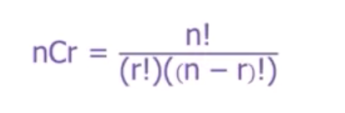
  + **Remember 1, 4, 6, 4, 1** - (Choose for 4)
    - Note: Use combinations for picking **X slots from Y -** Y might be different to the number of items available (e.g., slots in missing 5-digit number question)
    - For permutations, calculating the total number - determine the number of options (**remember no choice is an ‘option’**) and multiply
* **Series**
  + **Arithmetic series**
    - Total sum = n/2(2a + (n-1)*d) = n/2*(a_1 + a_n)
* **Geometry**
  + Angles
    - A = C, B = D  
      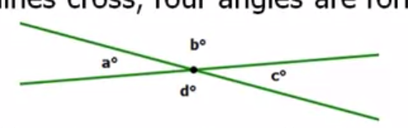
  + **Triangles:**
    - **Possible to determine area given length of a, b, c**
    - Equilateral triangles are **also isosceles** (special case)
      * Triangles can have multiple ‘shapes’ even if 1-2 dimensions are known (e.g., **angle can be small or large**). Important for ‘sufficiency’ questions
    - Extending base of triangle to calculate altitude (and area) - can be used to find interesting properties of triangle
      * 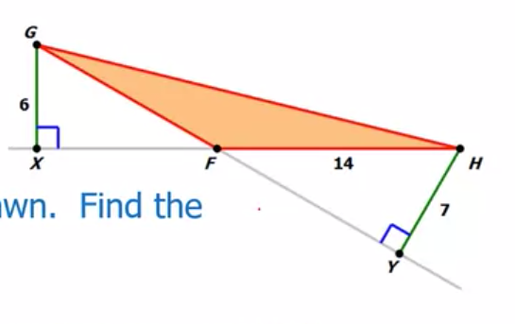
    - Other important lines to note:
      * Altitude (as defined above - used to find area)
      * Perpendicular bisector - every point on bisector of AB is equidistant from A and B
      * Median bisector - divides opposite side in half (note: angle not divided in half)
      * Angle bisector - divides angle in half (note: opposite side not divided in half)
    - Triangle inequality: **|a-b| < |c| < |a+b|**
    - Triangles are ‘similar’ if they share the same angles
    - If **Right-triangle, think pythagoras**
  + **Quadrilaterals**
    - Area of rhombus / parallelogram: A = bh where h is the ‘altitude’
    - For a trapezium, A = mean(b1, b2)*h
    - Consider splitting apart ‘slanty’ shapes in right-triangles to simplify the area calculation
    - Isosceles trapezoids **share the same angle** if both ‘slants’ are the same length (hence isosceles)
    - **Length bounded: a + b + c <= d**
  + **Polygons**
    - For an n-sided shape, we can draw (n-3) diagonals, resulting in (n-2) triangles, to produce **(n-2)*180** total sum of angles
    - **Rhombus area = side-length * altitude**
    - **Bisecting the shape** splits internal angles in **half**
    - **Octagon** - Supplement of internal angle is 45 degrees
    - **Hexagon** - Supplement of internal angle is 60 degrees
  + **Circles**
    - Chords connect any two points on edges
    - The arc of two chords is **2* the** **angle between two chords** 
      * 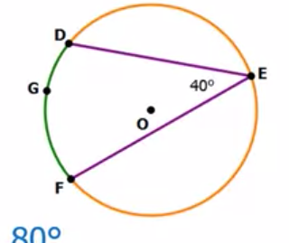
    - If there are a set of chords that produce a line of same length as DF above, then this chords have the same arc angle
    - Inscribed angles sharing the same arc or chord are equal
      * 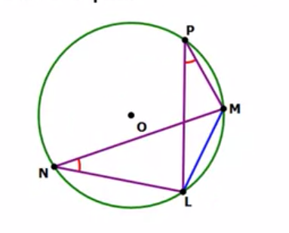
    - An angle inscribed in a semi-circle (opposite the diameter) = 90 degrees
    - The angle between tangent and radius = 90 degrees
      * 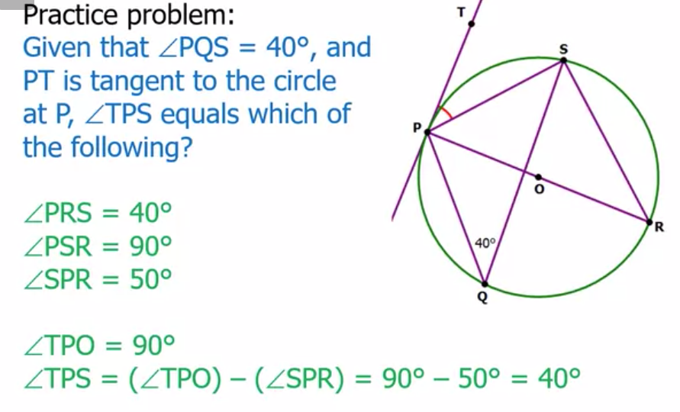
* **Probability**
  + If question uses ‘mutually exclusive’ / ‘independent’, or relates to coins/cards/die, or mentions P(A) = X, P(B) = Y - use algebraic rules
  + Else: use combinations (unless the list length < 3)
* **Quantitative comparison questions**
  + Do not calculate the answer to the question if you do not have to! Estimation + comparison is just enough!
  + Is the question asking for **an integer or a decimal? How would that affect the answer of the comparison question?**
  + Determine if comparison can be simplified to make answers easier
    - **Cross-multiply** to simplify problem
    - Add / divide terms on both sides to simplify problems
  + Inequality:
    - Addition / Subtraction on both sides of inequality preserves order
    - Multiplication / Division by **positive** number preserves order of inequality
    - Multiplication / Division by **negative** number reverses order of inequality
    - If the variable is not know to be positive - then you **cannot multiply and/or take square roots etc.**
      * Note: Cube (roots) preserve inequality order
    - Expressing something as **a perfect square** is easier than applying quadratic formula - e.g., x**2 + 16x + 67 = (x+8)**2 + 3
  + Calculate worst-case **of value** (e.g., any triangle of length 6, 4 will have largest area it 0.5 * 6 * 4 = 12)